JLR-IMMO
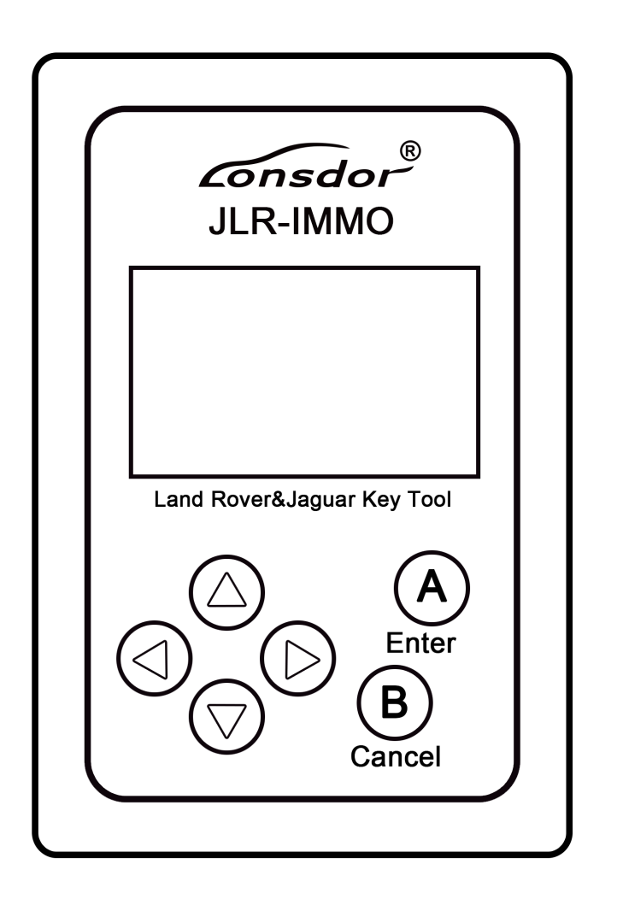

Lonsdor JLR-IMMO

User Manual
1. Product description
JLR-IMMO is a dedicated IMMO device for Jaguar and LandRover, launched by Shenzhen Lonsdor technology company. It’s designed to program car keys and applicable to above 95% of Jaguar and LandRover models currently (VPW protocols of Jaguar’s old model is unsupported). JLR-IMMO supports OBD program mode, and more than 50 software versions for KVM as well. A majority of KVM case is dismantle-free and can be programmed with this device.
2. Registration and activation
(1) Please enter the site: http://u.lonsdor.com/jlrimmo/login
① Login
User who’ve bound Lonsdor product: input account, password and verification code to login.
User who doesn’t bind Lonsdor product: click【Register】and follow prompt messages to complete registration, then log in.
② Bind device: after login succeed, check system prompts when device boots. Input the device No. & registration code as per the prompts, and set device password. Click 【Submit】to bind device.
(2) After bind device successfully, enter the site: http://u.lonsdor.com
① Click JLR-IMMO button, click【Get activation code】, confirm that device No. shown on the webpage is consistent with actual device No. Click【Submit】to get activation code.
② Input device No. on webpage to the device to activate it.
3. Supported vehicle
(1) LandRover 2008-: Immobilizer and smart key
(2) LandRover Discovery3: Immobilizer
(3) LandRover Freelander: Immobilizer and smart key
(4) LandRover Freelander2: Immobilizer and smart key
(5)LandRover Discovery4: smart key
(6) LandRover Evoque: smart key
(7) LandRover Defender: remote
(8) LandRover new models KVM case’s software version: FK72
(9) LandRover new models KVM case’s software version: HPLA
(10) Jaguar XF: smart key
(11) Jaguar SJ: smart key
(12) Jaguar F-TYPE: smart key

Lonsdor JLR-IMMO

(13) Jaguar X-TYPE: Immobilizer
(14) Jaguar Soverign: Immobilizer
(15) Jaguar XJ6: Immobilizer
(16) Jaguar XJ8: Immobilizer
(17) Jaguar XJR: Immobilizer
(18) Jaguar XK: remote
(19) Jaguar XKR: remote
(20) Jaguar new models KVM case’s software version: FK72
(21) Jaguar new models KVM case’s software version: HPLA

4. Device software updates
To update the device software, enter the site: http://u.lonsdor.com, to download update toolkit. Then according to instructions in the toolkit to update JLR_IMMO device program.

LonsdorJLR-IMMO
Product Warranty Card

Customer Name: ______________________________________ ( Mr. / Ms. )

Mob: __________________________________________________________

Email:_________________________________________________________

Address: __________________________________________________________

_______________________________________________________________

Device Model: __________________________________________________

Serial No.: _____________________________________________________

Returned items details:___________________________________________

_______________________________________________________________

Problem description in details: _____________________________________

_______________________________________________________________

_______________________________________________________________

Sending date:____________________

1. Lonsdor provides quality after-sales service and agreed within the scope of warranty.
2. The warranty period will last 12 months from the activation date.
3. For any device problem, please first ask your agent for a solution, also you can send problem description in details to service@lonsdor.com for direct help from Lonsdor in an emergency situation.
4. In case of device fault or damage, which need to be sent back for repair or replacement, please contact your dealer to deal with it.
Note: Lonsdor will not handle any device replacement with end user directly.

