How to change MB Star diagnosis DAS Xentry language

How to change DAS language:
Step 1. You need to choose the DAS icon on desktop, and right-click , then choose the option:
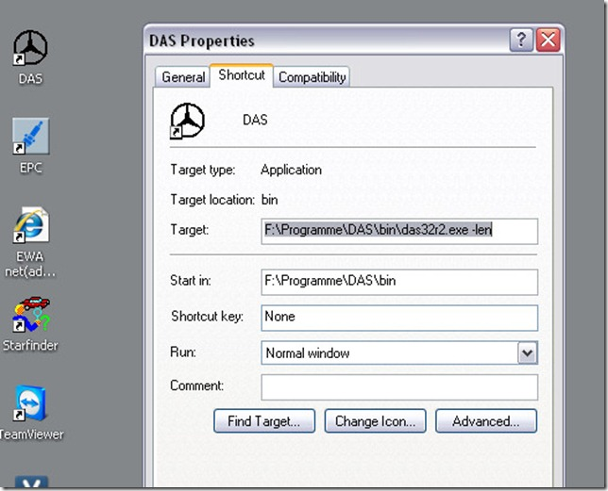
Step 2. Change the “-len” to “-lde” as below:
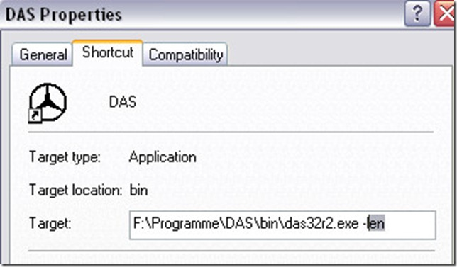
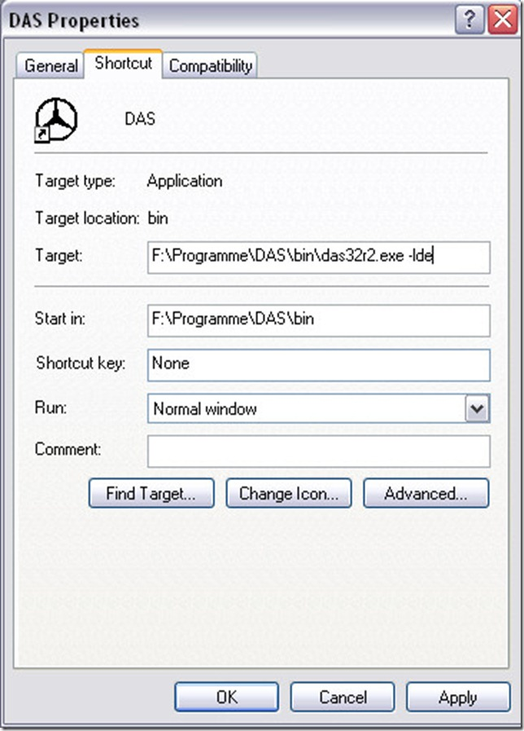
Then click “OK”, then it is okay

How to change Xentry Language:

It is also very easy to change.
Step 1. Run Xentry, and click the setting icon.
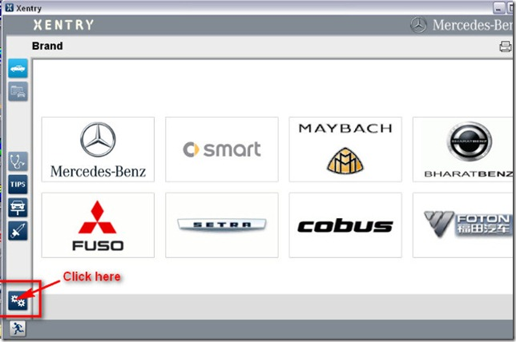
Step 2. In the system setting , you will see Setting language, click it.
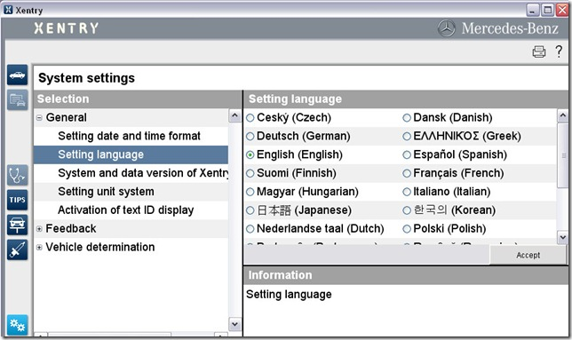
Step 3. Now we can see all available language, we chosen Deutsch(German), then click accept.
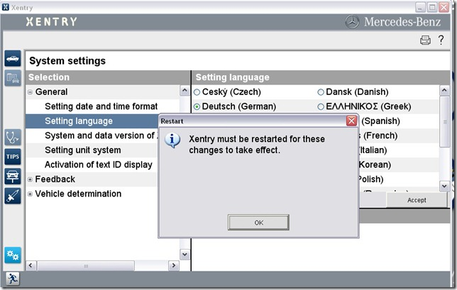
Now DAS and Xenry language have changed.

